**Retail Management System**

In this project, I have considered a fictional retail supermarket “K-mart” situated in different cities across India. This supermarket is a fast growing supermarket due to their services and variety of items they provide under a single roof.

Sample of data from their databases : -

DDL Commands Link :

[**https://drive.google.com/file/d/1I-leXfH5DMrSIqfIKQ0vsoeLXdAXjKY_/view?usp=sharing**](https://drive.google.com/file/d/1I-leXfH5DMrSIqfIKQ0vsoeLXdAXjKY_/view?usp=sharing)

In this project, I have used MySql workbench to execute my queries. Also I have used google docs in order to present it. Please open this file in Google Docs for the best view.

**Data Overview :**

Database consists of 5 tables. In order to better understand the data I have made a schema of the database using reverse engineering in My Sql Workbench.

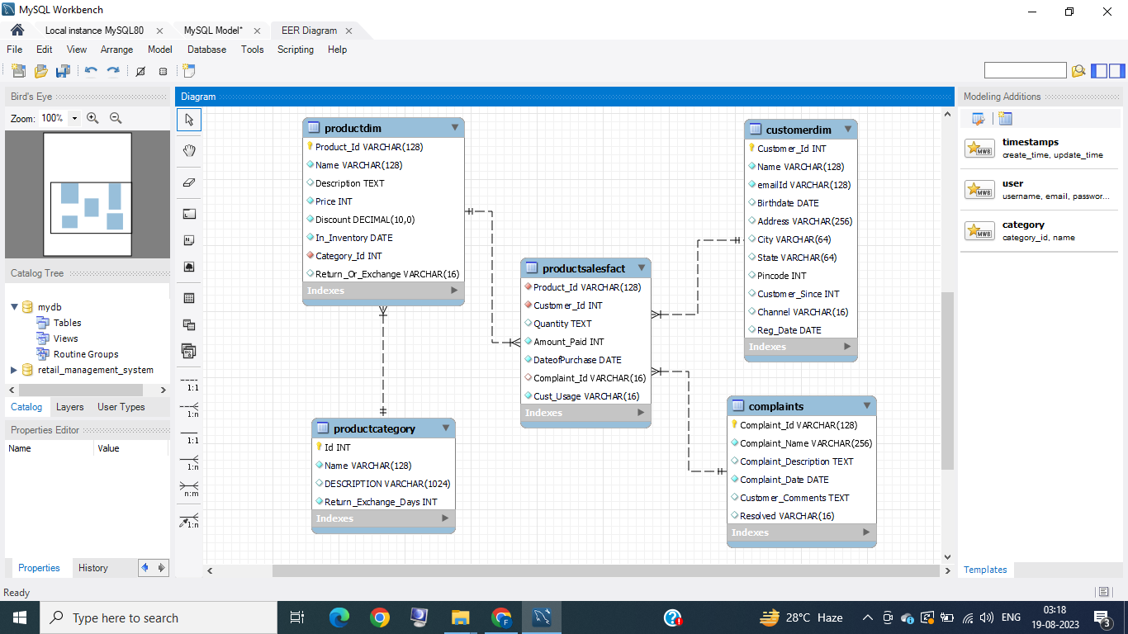

**Data Analysis :**

Here in this section, I have displayed all the questions which I have answered in this project.

**Queries used :**

To write queries answering all of the questions below in MySQL , I have created a Database in MySQL Workbench. I am attaching the file for all the Queries which I have used to answer all the questions in both .sql and .txt format.

.txt link - [Retail Management System MySql Queries(Text FIle)](https://drive.google.com/file/d/1hRY3mmzBRVj8TgKqGIjiLs2DqRbj_U_l/view?usp=sharing)

.sql link - [Retail Management System MySql Queries(SQL Format)](https://drive.google.com/file/d/1s6kb1jVg9g7B8o1j35OCJF7PlWrsYHWo/view?usp=sharing)

**Section 1**:

**1.** Identifying the oldest customers in our database.

**2.** Identifying the top 5 customers having a lot of purchase activity on our platform in the last quarter.

3.Identifying the customers with bulk purchasing orders in different usage segments in the last quarter.

**“The Company can give rewards to loyal customers using the result of above queries. They can either provide high discount coupons or may decide to give the products for free to the customers as a loyalty reward.”**

**Extra Question :-**

**Based on the above identified customers, I have created a string for top customers having frequent purchase activity in different usage segments in format “Congratulations {Customer_Name}! You are eligible for a coupon of 75% off up to 5000 INR to be redeemed till {date}. You can find that in your email.”**

**Section 2 :**

**“Let’s suppose we want to limit the customers to certain product categories that they can spend their discount coupon on. We can try to identify the categories that they like using below questions”**

Identifying the following:

1. No. of products that are 300 days older in our inventory by

a. Product category sorted by the total stock price.  
b. Product category with Return or Exchange type sorted by the total stock price.

2. Identifying the product category which customers have bought a lot in each month in different usage segments ordered by their frequencies.

**“Here by providing discount coupons we can encourage customers to buy products which have been in inventory for a long time.”**

**Section 3**

**Considering the scenario that we have quite a lot of complaints for different products in product categories. An organization can’t resolve all the queries at the same time so they try to prioritize the complaints received in highest volumes first.**

1. Identifying the total number of complaints by

a. Product category along with query resolved or not

b. Complaint_Name

2. Identifying the fraction of complaints that are resolved by each product category vs fraction of complaints that aren’t resolved by each product category.

**“Here we can get to know the frequency of different complaint types and we can work on reducing them. We can also know about the products which are causing the maximum number of complaints.”**

**Section 4**

**In this section ,I have ranked customers, products and complaints based on different criterias to understand their position in the data.**

1. Ranking the customers based on

a. Total purchasing they have done in terms of amount in descending order  
 b. Total quantities they have purchased by descending order

2. Identifying the top 1 ranking product/s within each product category by their

a. Price.  
 b. Number of days they are in inventory from the current date.

3. Ranking the complaints that are not resolved by their number of days. Categorizing the results by the Complaint Name

**“Here, I have identified customers who purchased maximum products and spent the maximum amount. Also, I have identified the top products in each category by their price and also found out the products which are in inventory for the longest time. Ranking the complaints which are not resolved from the longest time help us identify the complaints which need to be addressed first.”**

**Section 5**

1. Comparing the total purchase by amount that happened on a week by week basis.

2. Comparing the number of customers that you witness week-by-week on your platform.

**“Using the result of these queries we have tried to identify if the total sale and number of customers increases or decreases on the weekly basis. By observing the trend, stores can take necessary decisions to increase their revenue.”**

**Section 6**

1. Dividing the household customer into 3 segments: highPurchase, mediumPurchase and lowPurchase based on ranking of customers by their total purchase amount (first 25% in low, 25 to 75 medium and > 75% high)

And calculating:

1. Number of customers in each segment.  
 2. Total purchase within each segment in terms of

-Quantity

-Purchase amount

**“By doing this analysis we get the idea about the number of customers, total quantity they purchased and total purchase amount in each segment. This can help us in targeting those customers which contribute the most to the company's revenue. “**

**Section 7**

**“In this section I have tried to showcase my skill of creating functions, procedures and views in MySql”**

1. Creating functions for the following:

1. Getting the age of the customer.  
 2. Get the full address of a customer [By concating city, state, etc. to address]

2. Creating Views using above functions:

1. Identifying the customers by different age group/segments - 10-19, 20-30, 30-60, >60 and get the total amount of products they have purchased in each segment.  
2. Displaying message for bulk order item (quantity >= 10) - “Sorry, the order delivery to your {Full Address} is delayed by 2 days. It's expected to arrive on {date}” where the date is 2 days from now.

3. Considering that we want to display different images by age groups if their order is late. Writing a stored procedure where for bulk order item (quantity >=10) you have to an animation of ‘puppy’ for 10-19, ‘a warehouse person with loading box’ for 20-30, ‘a moving truck’ for 30-60 and a ‘puppy’ for >60 again [This will just be a column with Image type displayed]. Writing a stored procedure for the task given the Date of birth of the customer.